
Department of Mechanical Engineering

EMCH 368
MECHATRONICS

Lab 4
LCD

Last Edited 01/30/24 by J. Vaught

New Materials List

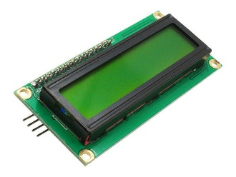
An LCD (liquid crystal display), like the one included in your Arduino kit, is a versatile technology for displaying alphanumeric characters. This specific screen is capable of showing 32 characters across 16 columns and 2 rows. These displays are typically selected for their crisp, clear visuals and low power usage. LCDs operate by manipulating light through liquid crystals and polarized glass. When electric signals from the Arduino are applied, these crystals change orientation, either blocking or allowing light to pass through, thus forming characters and symbols.

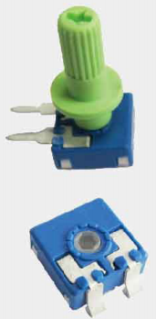
Accompanying the LCD in the kit is a potentiometer, a type of variable resistor. It has three terminals: two are connected to a fixed resistor, and the middle one, known as the wiper, slides across this resistance. As you turn the potentiometer's knob, you change the resistance between the middle terminal and each of the outer terminals. This alteration in resistance translates to a change in voltage at the middle terminal, effectively giving you a variable voltage control. Commonly found in various electronic devices, potentiometers are essential for applications like adjusting volume or tuning settings, where gradual changes in resistance and voltage are required.

Exercise 1: Interactive Random Response LCD Display
Create an interactive digital Magic8 Ball using an Arduino and an LCD screen. Instead of shaking the ball to get an answer, users will press a button to receive random responses displayed on the screen. The project will also feature an adjustable LCD screen contrast controlled by a potentiometer.
Objectives:
- Use an LCD screen to visually display text responses.
- Implement a potentiometer to adjust the screen's contrast.
- Begin the program with a message inviting the user to "ask the Crystal Ball".
- Generate 8 random responses, such as "Yes," "No," or "Maybe someday…".
- Use a pushbutton to trigger a new random response each time it's pressed.
Materials Needed:
- 1 set of long red and black jumper wires
- 1 pushbutton
- 1 10k-ohm resistor
- 1 LCD screen
- 1 potentiometer
- 1 220-ohm resistor
Circuit Assembly Guide:
Note: Pay careful attention to the wiring to avoid damaging the LCD screen. If you're unsure, seek help from your instructor.
- Connect the Arduino's 5V pin to the breadboard's (+) power bus and the ground pin to the (-) ground bus for the circuit's power supply and grounding.
- Install the pushbutton on the breadboard, connecting one side to power and the other to both the ground (through a 10k-ohm resistor) and digital pin 6 on the Arduino.
- Position the potentiometer on the breadboard, connect the top leg to power, and the bottom leg to ground. Wire the middle pin to the V0 pin on the LCD to control contrast.
- Wire the LCD pins VSS, LED-, and the R/W pin to ground.
- Connect the LCD pin VCC to power.
- Link the LCD pin LED+ to power via a 220-ohm resistor for current limiting.
- Set up the data connections from the Arduino to the LCD:
  - Digital pin 2 to LCD D7
  - Digital pin 3 to LCD D6
  - Digital pin 4 to LCD D5
  - Digital pin 5 to LCD D4
- Connect the LCD pin EN to Arduino digital pin 11 to enable writing to the display.
- Hook up the LCD pin RS to Arduino digital pin 12, toggling data & instruction registers.
- Finally, connect the Arduino to USB to upload your Magic8 Ball program.

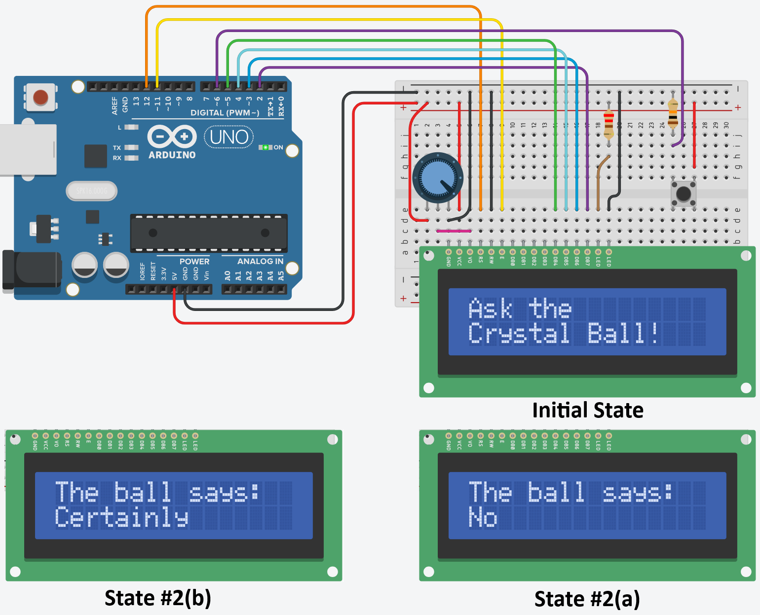
Exercise 1 Circuit
Writing the Program:
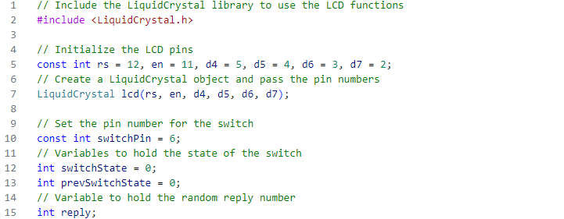
First, we initialize the connection to an LCD display using the Arduino's LiquidCrystal library, which abstracts the complexities of manipulating the LCD's pins for display purposes. It defines constants for the LCD's pin connections, establishes a LiquidCrystal object with these pins, and sets up variables to track the state of a connected switch, including a variable for storing the reply number that will be used to display random messages on the LCD.

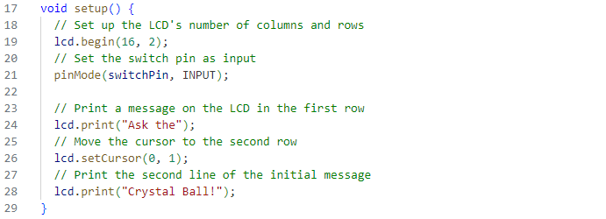
In the setup() function, the switch is configured as an input to the Arduino, and the LCD is initialized to a 16x2 character format. Text is displayed on the LCD with the lcd.print() function, starting at the top left corner (0,0 coordinates), and the cursor is moved to the beginning of the second line using lcd.setCursor() to set up a welcoming message across the two rows.

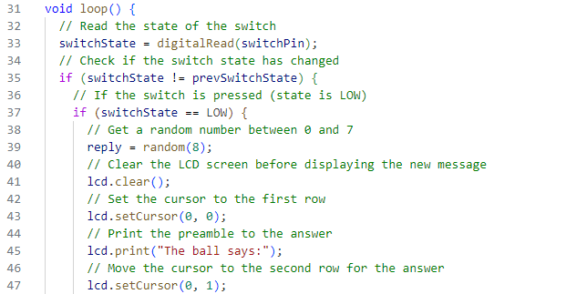
In the loop() function, the state of the switch is read and compared to its previous state to detect any changes, such as a tilt from a shake, indicated by a transition from HIGH to LOW. If a change is detected, a random number from 0 to 7 is assigned to reply. The LCD is cleared to refresh the display, and the cursor is reset to the top-left to introduce the message with "The ball says:". Subsequently, the cursor is moved to the second line in preparation for displaying one of the eight possible responses.

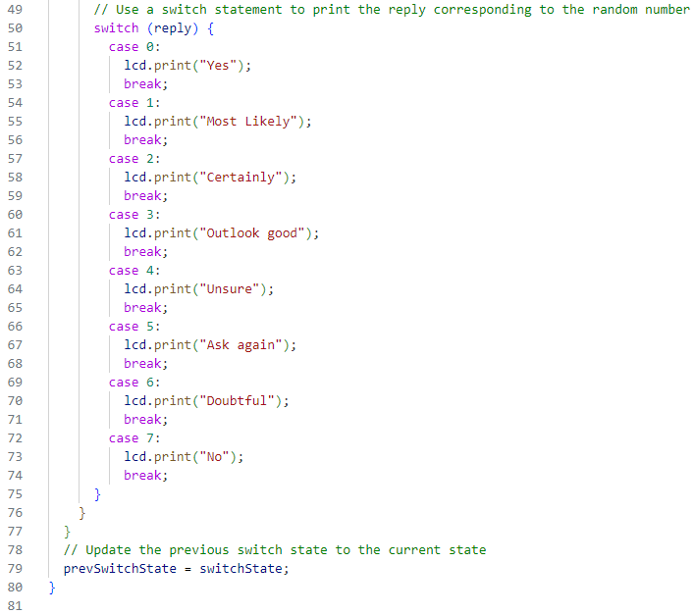
The switch statement in the code selects one of several code blocks to execute, based on the random reply number. Each block, or case, contains a unique message to be displayed on the LCD using lcd.print(). After printing the message, break terminates the case, ensuring that no subsequent cases are executed. As the loop concludes, prevSwitchState is updated with the current switchState to prepare for the next cycle, allowing the program to track changes in the switch's position on subsequent iterations.

Use the circuit:
Upload the code to the Arduino and switch it on to begin the interaction. The LCD will show the initial message "Ask the Crystal Ball!" To generate a response, press the button connected to your Arduino. Once pressed, the LCD will refresh to display "The ball says" on the top line and one of the eight possible answers on the bottom line. If you press the button and no text appears on the screen, you might need to adjust the contrast by turning the potentiometer until the words are clearly readable.

Exercise 2: Creating an LCD Stopwatch
Building on the previous Exercise, create an interactive stopwatch using an Arduino circuit that can start/stop and track lap times with the push of buttons, featuring an adjustable LCD screen contrast controlled by a potentiometer.

Objectives:
- Adjust the LCD contrast with a potentiometer.
- Display a welcome message on the LCD at startup.
- Start a timer with a 'start' button, showing minutes and seconds on the LCD's top line.
- Record lap times with a 'lap' button, displayed on the LCD's bottom line.
- Use the start button to reset and pause the timer at any time.

Materials Needed:
- Long red and black jumper wires
- A potentiometer
- An LCD screen
- Two pushbutton switches
- Two 10k-ohm resistors
- One 220-ohm resistor

Circuit Assembly Guide:
Caution: Ensure the USB power is disconnected before making changes to the circuit to prevent damage to the LCD.

- Start by disconnecting the USB power to avoid any electrical mishaps.
- If Exercise #1 is complete, start at Step 3. Otherwise, follow Steps 1-10 in Exercise #1.
- Install the second pushbutton on the breadboard, straddling the central divide. Wire one side to the 5V power supply and the other to both the digital pin 7 and ground, through a 10-kilohm resistor. This button starts recording lap times. The button from Exercise #1 will start/stop the timer.
- Reconnect the USB power to the Arduino and upload your stopwatch program.

Note: With multiple wires to manage, take special care to follow the correct wiring path for each component. If you're unsure or something doesn't seem right, don't hesitate to ask your instructor for help.

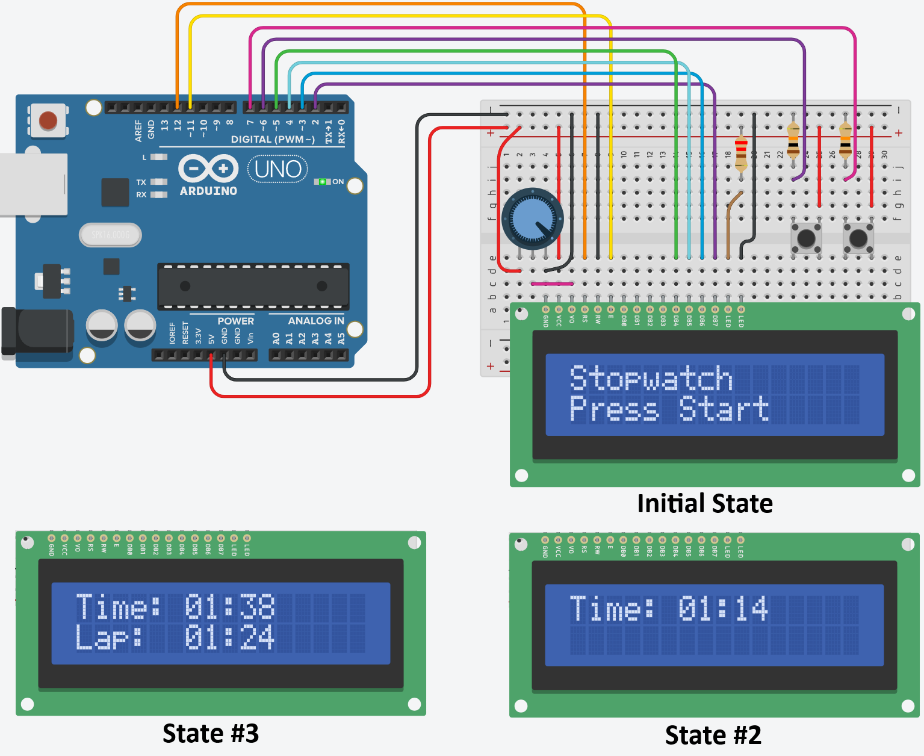
Exercise 2 Circuit
Writing the Program:
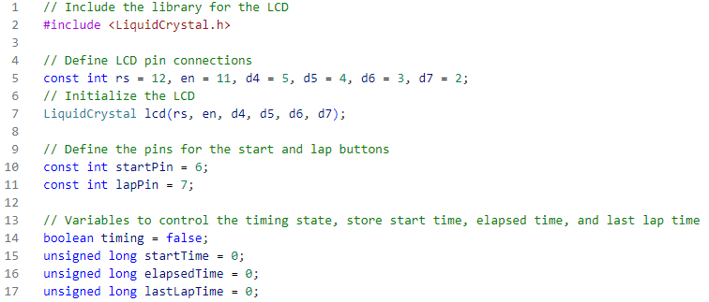
First, we import the LCD library, define all global constants and variables, pins, and instantiate the LCD screen.
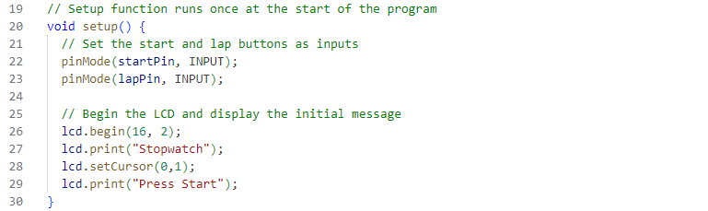
In the void setup(), the start and lap pin inputs can be defined using the pinMode function. Use lcd.begin() to define how large the LCD screen is. Then create the initial screen display for the LCD. Display “Stopwatch” on the first line and “Press Start” on the second line.

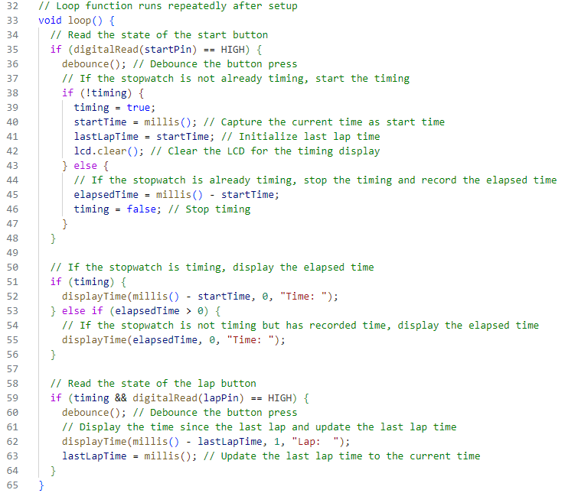
The loop() function continuously checks for button presses to control the stopwatch. Pressing the start button begins or ends timing, with millis() tracking the start and elapsed time. While timing, the elapsed time displays continuously. Pressing the lap button records and shows the time since the last lap. Button presses are stabilized using a debounce delay to prevent false triggers.

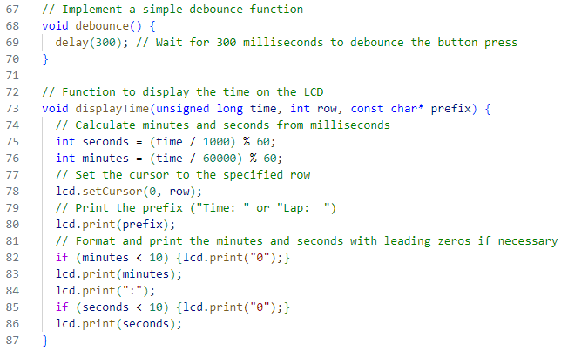
The debounce() function in this code is used to manage the physical characteristics of the button press. When you press a button, it doesn't simply change from LOW to HIGH instantly; it may rapidly flicker between these states before settling. This function waits for a short period (300 milliseconds) to ensure that any "bouncing" has stopped and we have a stable HIGH or LOW reading from the button.

The displayTime() function handles the display of time on the LCD screen. It takes the current time in milliseconds, the row of the LCD to display the time on, and a text prefix indicating what the time represents (like "Time: " or "Lap: "). It calculates the minutes and seconds from the given milliseconds, sets the cursor to the specified row, prints the prefix, and then prints the formatted time with leading zeros where necessary. This makes sure the time is displayed in a human-readable MM:SS format.

Use the Circuit:
After uploading the code and beginning the program, “Stopwatch | Press Start” should appear on the LCD screen. When you press the start button, the screen should clear and be replaced with the timer which will begin counting up. By pressing the lap button, the second line will display the word “lap” as well as your last lap time. How accurate is this timer? Compare your Arduino timer with the one on your phone. Does it count seconds at the same rate?

Challenge Exercise: Creating a Voltmeter
This is an UNGUIDED Exercise, meaning there are a few components left out from the directions; in this case, you are requested to develop the code for this without explicit direction from the TAs or Instructor.
Build a basic voltmeter using Arduino. The device will display the average voltage measured over 2 seconds at the potentiometer's middle terminal onto an LCD screen.

Materials:
- Arduino UNO
- LCD screen
- Potentiometer
- Pushbutton

Circuit:
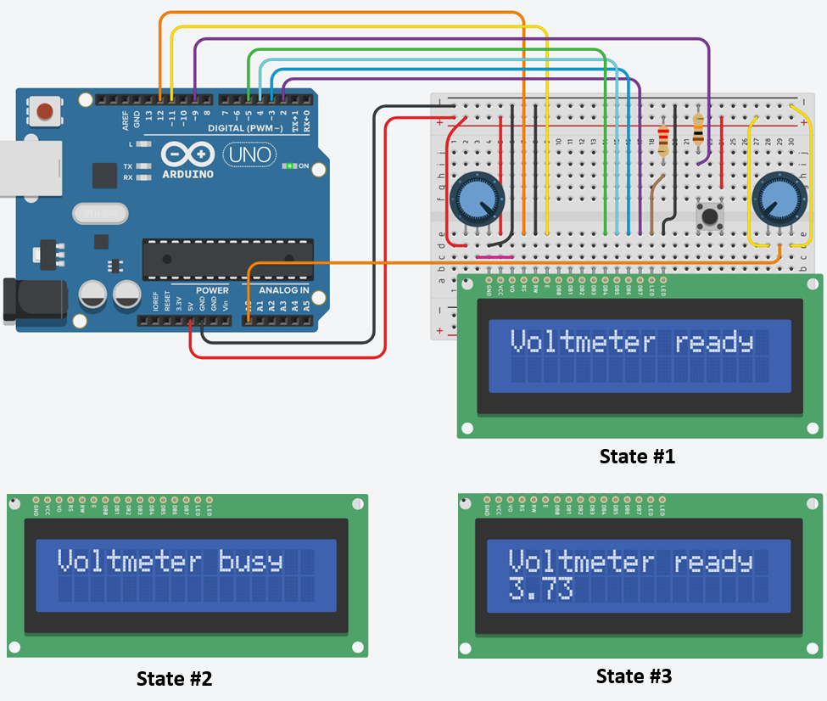
Challenge Exercise Circuit

Code Requirements:
- Initialize the LCD to display "Voltmeter ready" on the first line.
- When the button is pressed, start the voltage measurement routine, which consists of 2000 individual readings from the potentiometer. These readings are spaced out with a 1-millisecond delay for pacing.
- While taking measurements, the LCD should indicate "Voltmeter busy".
- Perform an Incremental Averaging calculation to determine the average voltage, updating this average with each new reading without the need to store each value, using the formula:
new_average=old_average+(new_measurement-old_average)/current_number_of_measurements;
- After the measurements are complete, display "Voltmeter ready" again and show the calculated average voltage on the second line of the LCD.
- The system should reset and await another button press to repeat the measurement process.

For FULL credit, you must follow the following steps:
- Convert the analog reading to volts using the map() function.
- Use a falling edge trigger: The device starts measuring when the button is released after pressing.
- During measurements, the device should ignore further button presses.

Code and Hardware Explanation:
- You will need to explain how your code and hardware setup works, referencing previous labs.

Key Learning Points:
- Understanding signal edges: Signal Edge Detection
- Pros and cons of Incremental Averaging: Incremental Averaging
- Writing readable code: Code Readability Guide

Lab 4 Code Appendix (in order of appearance):
- #include – This directive imports external libraries, essential for enabling certain functionalities in your code. Libraries contain pre-written code for specific tasks, making complex operations more manageable.
- lcd.begin(columns, rows) – Initializes the LCD screen, specifying its dimensions as the number of columns and rows. This function sets up the screen for displaying text according to its physical layout.
- lcd.print(text) – Displays the specified text on the LCD screen. This function converts your text data into a format that can be visually represented on the LCD.
- random(max#) – Generates a pseudo-random number within a specified range, from 0 up to (but not including) the maximum number defined. This function is useful for creating variability in your program's behavior.
- lcd.clear() – Erases all displayed content on the LCD screen, resetting it to a blank state. This function also resets the cursor to the top-left corner of the screen, preparing it for new content.
- lcd.setCursor(column, row) – Moves the LCD cursor to a specific location defined by the column and row coordinates. This function is vital for controlling where your text starts on the screen.
- switch...case – A control structure that directs the flow of the program based on the value of a variable. It compares the variable against a series of case values and executes the matching block of code. This structure is a more efficient alternative to multiple if-else statements for certain scenarios.
- break – Used within switch...case structures, it signifies the end of a case block. When encountered, the program breaks out of the switch statement, preventing the execution of subsequent cases.
- boolean – A primitive data type representing one of two values: true or false. Booleans are fundamental in controlling the flow of logic in a program, often used in conditional statements.
- % (Modulo Operator) – Performs division between two integers and returns the remainder. For example, x = 7 % 5 results in x being 2. It's particularly useful in situations where you need to cycle through a range of values or determine if a number is divisible by another.
- Functions – Blocks of code designed to perform specific tasks, functions help streamline your code by reducing redundancy. They can be called multiple times within a program, enhancing readability and maintainability. Functions are central to structured and modular programming.
Lab 4 Grading Rubric:
- Exercise 2 Circuit fully built. (10 points)
- Exercise #1 works (10 points)
- Exercise #2 works (10 points)
- Comprehension Tasks (10 points)
- Challenge Exercise (10 points)
Grade distribution template (total 50 points)
- 10 points for built, but not working exercise 2 circuit.
- Exercise grade = (20 points/# of exercises) * (0, 0.5, 1) = zero, half or full exercise grade.
- 10 points for competent and complete responses to any comprehension tasks.
- 10 points for a working device that meets all stated requirements.

